Directions
Create a list of rules to help your family have device-free moments. Remember, the rules aren't just for you, but for everyone you live with. You can write special rules for certain people. Be the boss. You’re in charge!

Our Family Device-Free Rules

A device-free rule to stay safe: | A device-free rule to show respect:
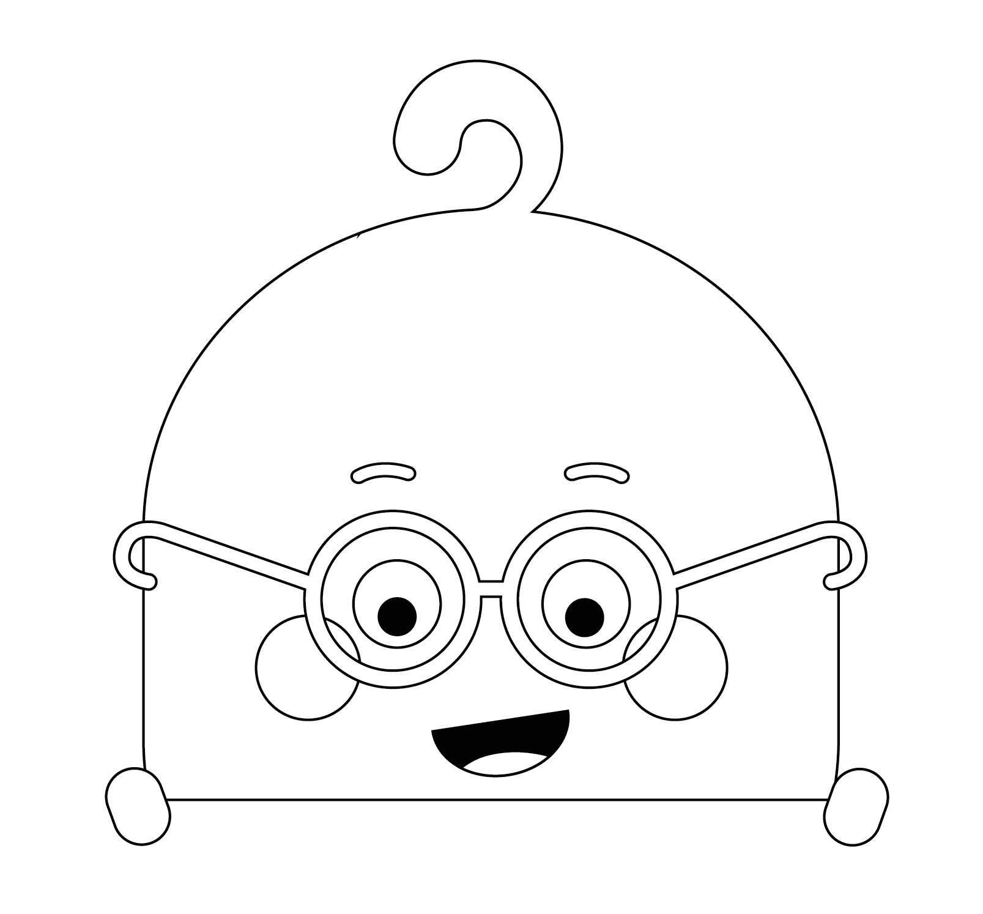  A device-free rule so we can concentrate: | 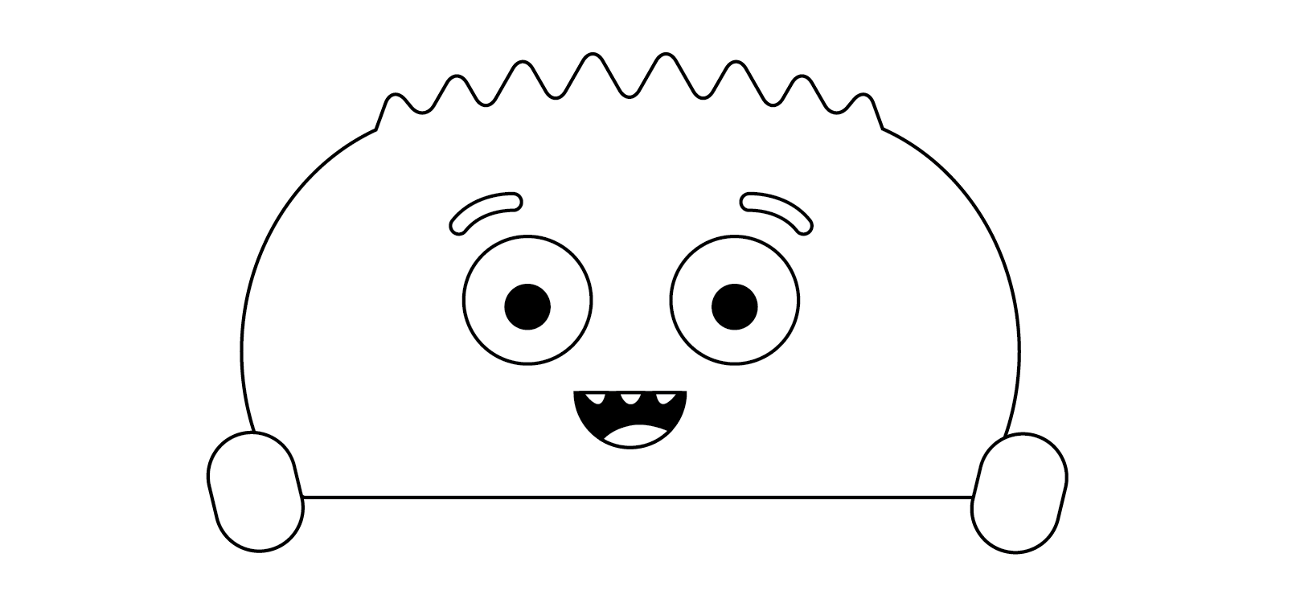  A device-free rule to get our sleep:

